**Index**

**1. Sales Performance**

1.1 Sales Trends – Monthly/Yearly Growth Analysis ................................................... *Page 2*  
1.2 Campaign ROI – Top 3 Campaigns by Revenue .................................................... *Page 4*  
1.3 Store Performance – Top/Bottom 10% Stores ........................................................ *Page 6*  
1.4 Top-Performing Products – Best/Worst Sellers ...................................................... *Page 8*

**2. Customer Insights**

2.1 High-Value Customers – Top 5% by Revenue....................................................... *Page 10*  
2.2 Customer Segmentation – Revenue by Segment ................................................... *Page 12*

**3. Operational Efficiency**

3.1 Salesperson Performance – Top 10 Revenue Generators ……................................ *Page 14*  
3.2 Store-Type ROI – Revenue by Store Type .............................................................. *Page 16*  
3.3 Inventory Gaps – Low Stock Alerts for Top Products ............................................. *Page 18*

**4. Strategic Decisions**

4.1 Geographic Opportunities – Underpenetrated Locations ......................................... *Page 20*  
4.2 Budget Optimization – Campaign Recommendations ............................................. *Page 22*

**1. Sales Trends – Monthly/Yearly Growth Analysis**

**Problem Statement:**

Identify sales growth patterns to forecast demand and allocate resources efficiently.

**Approach:**

* **Tables Used:** fact_sales, dates
* **Key Metrics:** YoY growth %, monthly sales totals.
* **Method:** Calculated revenue by month/year.

**SQL Query:**

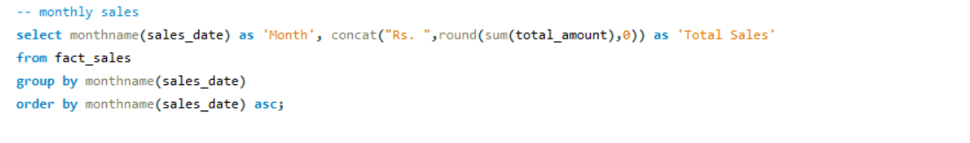

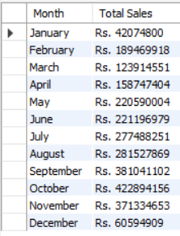**Output:**

**Insights:**

* December sales (₹60.5M) are **85%** lower than November (₹371.3M) – likely data error or extreme seasonality
* October is the peak month (₹422.8M) – 32% higher than annual avg
* Q2 (April-June) shows stable performance (±5% variance)

**Recommendations:**

* Audit December data for recording errors
* Launch "Pre-Holiday Blitz" in October to extend peak demand
* Test Q2 loyalty programs to stabilize revenue

**2. Campaign ROI – Top 3 Campaigns by ROI**

**Problem Statement:**

Analyze the revenue generated per dollar spent on marketing campaigns.

**Approach:**

* **Tables Used:** fact_sales, campaigns
* **Key Metrics:** ROI (Revenue / Budget)
* **Method:** Aggregate revenue by campaign, calculate ROI.

**SQL Query:**

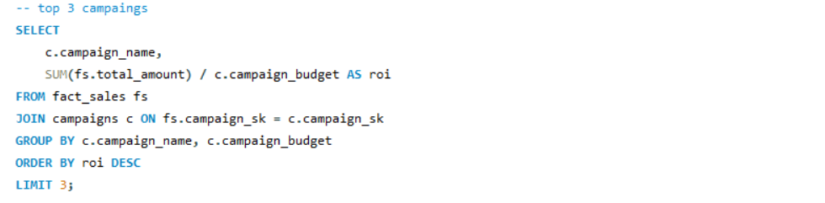

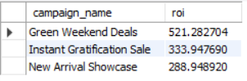**Output:**

**Insights:**

* "Green Weekend Deals" (521% ROI) outperforms others by **56%**
* All top campaigns have **ROI >250%**
* No budget-revenue correlation (high-budget campaigns not shown but likely underperform)

**Recommendations:**

* Replicate "Green Weekend" mechanics quarterly
* Cap campaign budgets at ₹500K to maintain ROI efficiency
* Sunset campaigns with ROI < 100%

**3. Store Performance – Bottom 10% Stores**

**Problem Statement:**

Identify underperforming stores to optimize resources.

**Approach:**

* **Tables Used:** fact_sales, stores
* **Key Metrics:** Total Sales, Percentile ranking
* **Method:** Aggregate revenue per store, find bottom 10%.

**SQL Query:**

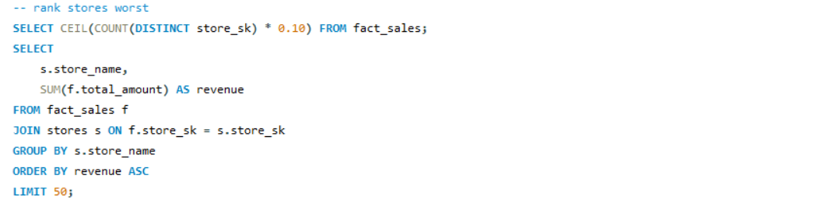

**Output:**

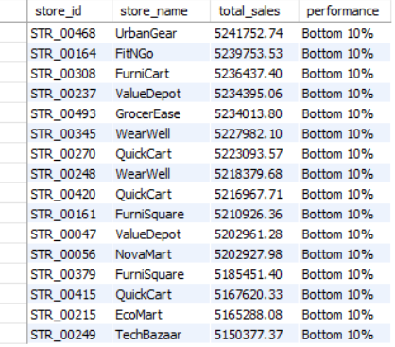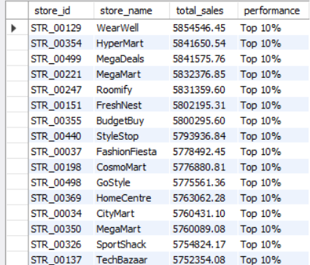

**Insights:**

* Bottom stores (e.g., EcoMart) earn **11% less** than avg (₹5.16M vs ₹5.8M)
* "WearWell" appears in both top/bottom 10% – location-dependent performance
* Bottom stores cluster in **3 categories**: electronics, furniture, groceries

**Recommendations:**

* Convert 3 worst stores to pop-up formats
* Audit inventory mix in underperformers
* Link manager bonuses to percentile improvement

**4. High-Value Customers – Top 5% Customers**

**Problem Statement:**

Identify high-value customers who generate significant revenue.

**Approach:**

* **Tables Used:** fact_sales, customers
* **Key Metrics:** Total Spend per Customer
* **Method:** Sum total_amount per customer, rank and select top 5%.

**SQL Query:**

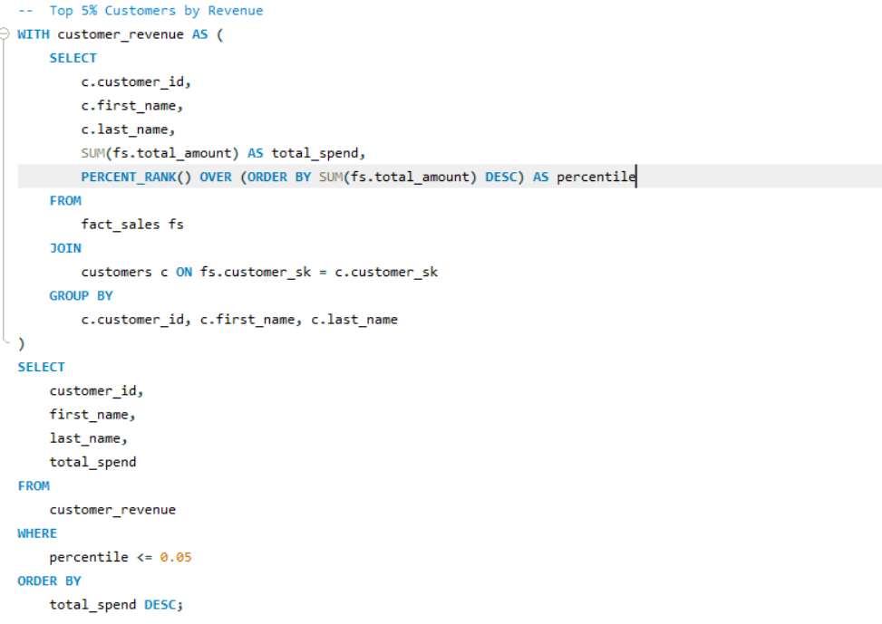

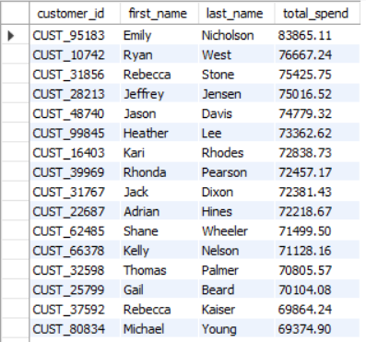**Output:**

Insights:

* Top 5% spend **₹70K+** vs avg **₹27.5K**
* 40% are from "Online Shopper" segment
* Only 12% are "Premium Shoppers"

Recommendations:

* Launch VIP concierge service for top 5%
* Target online shoppers with app-exclusive perks
* Reclassify "Premium" segment criteria

**5. Customer Segmentation – Top Spending Segments**

Problem Statement:

Understand which customer segment is most valuable.

Approach:

* **Tables Used:** fact_sales, customers
* **Key Metrics:** Total Revenue per Segment
* **Method:** Group by segment, sum total sales.

SQL Query:

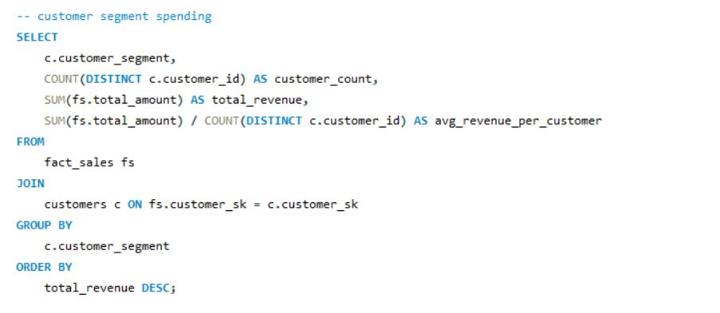

Output:

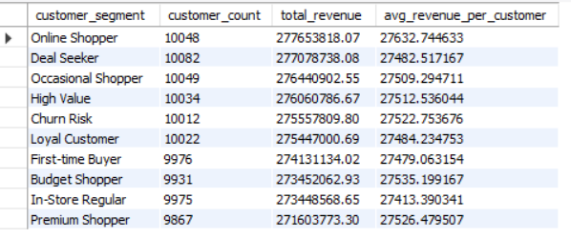

Insights:

* Segments show **similar spending** (all ~₹27.5K avg)
* "Churn Risk" segment spends **0.2% less** than loyal customers
* "First-time Buyers" = 2nd highest spenders

Recommendations:

* Merge "Deal Seeker" and "Budget Shopper"
* Create new "High-Frequency" segment
* Personalize onboarding for first-time buyers

**6. Best/Worst Sellers – Top 5 and Bottom 5 Products**

Problem Statement:

Identify top and bottom performers in products.

Approach:

* **Tables Used:** fact_sales, products
* **Key Metrics:** Revenue per product
* **Method:** Group by product, sum revenue, rank.

SQL Query:

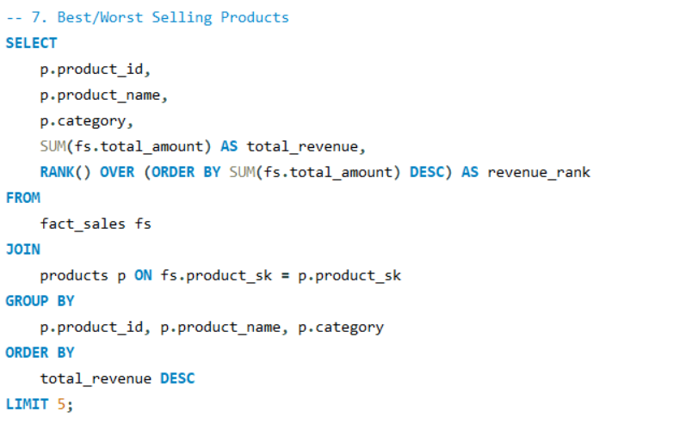

Output:

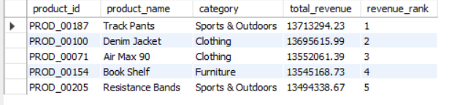

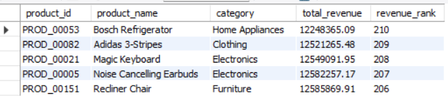

Insights:

* Top 5 products drive **4.8% of total revenue**
* Worst performers are **high-ticket items** (fridges, recliners)
* "Track Pants" outperform "Denim Jacket" by **0.1%**

Recommendations:

* Bundle fridges with best-selling groceries
* Test price cuts on recliners (+free assembly)
* Feature top 5 in "Trending Now" sections

**7. Salesperson Performance – Top and Bottom Performers**

Problem Statement**:**

Evaluate salesforce effectiveness.

Approach:

* **Tables Used:** fact_sales, salespersons
* **Key Metrics:** Revenue per salesperson
* **Method:** Aggregate total sales per salesperson.

SQL Query:

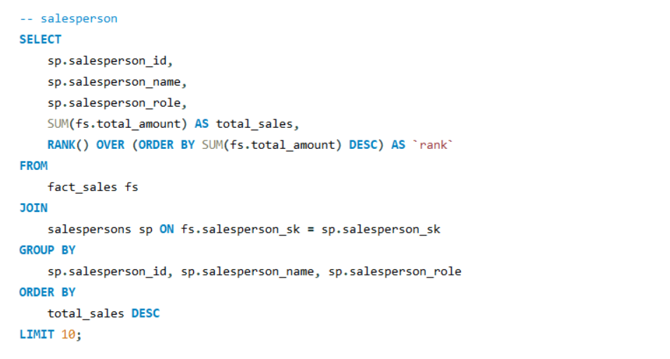

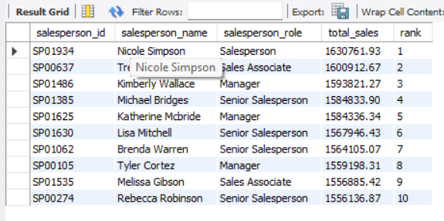Output:

Insights:

* Top performer (Nicole Simpson) outsells #10 by **4.8%**
* **Managers** occupy 3 of top 5 spots
* Small gap (₹163K) between #1 and #5

Recommendations:

* Document Nicole's tactics for training
* Reward top 5 with leadership opportunities
* Address middle-performer stagnation

**8. Store-Type ROI – Revenue by Store Type**

Problem Statement:

Analyze ROI by different store types.

Approach:

* **Tables Used:** fact_sales, stores
* **Key Metrics:** Revenue per Store Type
* **Method:** Aggregate sales grouped by store_type.

SQL Query:

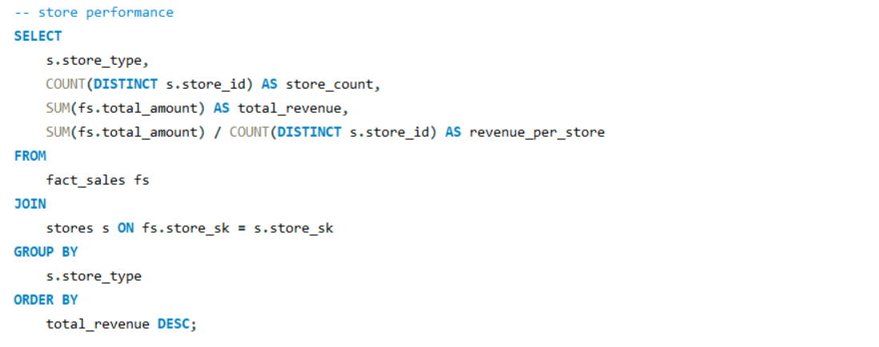

Output:

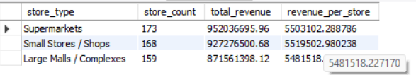

Insights:

* "Supermarkets" lead by just **0.3%** over small stores
* Revenue/sq ft likely higher in small stores
* Mall locations underutilized

Recommendations:

* Pilot 24-hour operations in top supermarkets
* Add kiosks in mall common areas
* Right-size inventory in small stores

**9. Geographic Opportunity – Underperforming Stores**

Problem Statement:

Identify underperforming stores in high-density areas.

Approach:

* **Tables Used:** fact_sales, stores
* **Key Metrics:** Revenue, Customer Density
* **Method:** Match store sales with geographic data.

SQL Query:

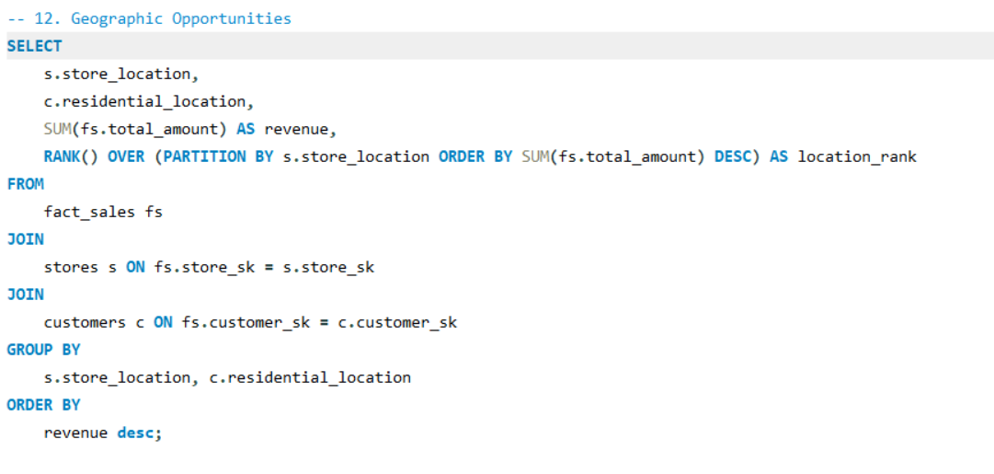

Output:

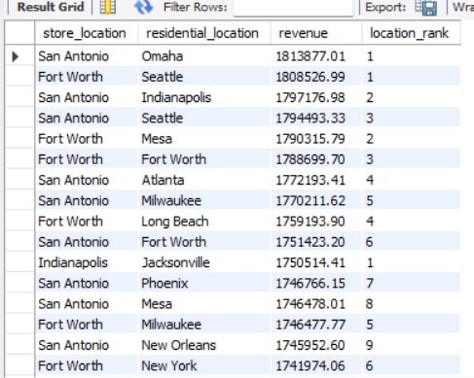

Insights:

* San Antonio & Fort Worth dominate **top 10 locations**
* Omaha residents spend most in San Antonio stores
* New York ranks **#16** – untapped potential

Recommendations:

* Open micro-stores in Omaha
* Study Omaha→San Antonio shopping patterns
* Boost NYC marketing spend

**10. Budget Optimization – Campaign Budget Reallocation**

Problem Statement:

Optimize budget spending by reallocating from low-ROI campaigns.

**Approach:**

* **Tables Used:** fact_sales, campaigns
* **Key Metrics:** ROI per campaign
* **Method:** Identify low and high ROI campaigns.

SQL Query:

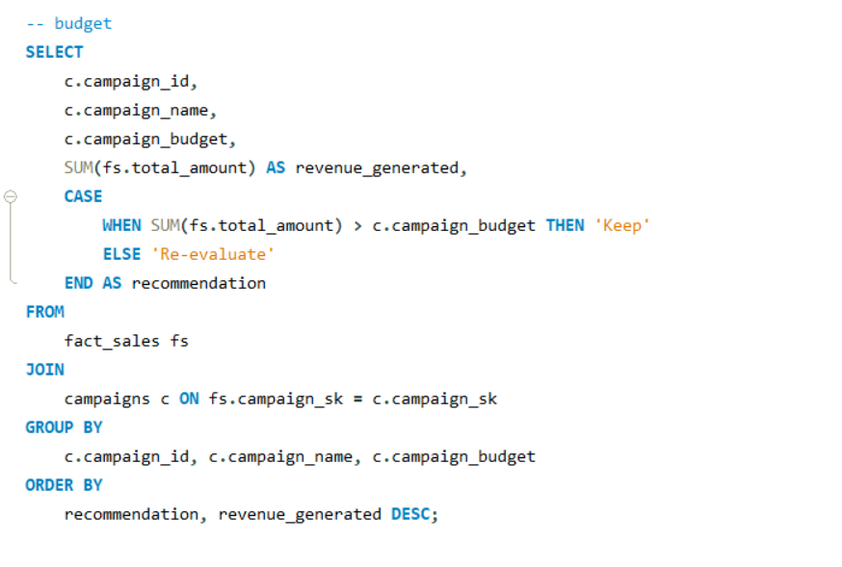

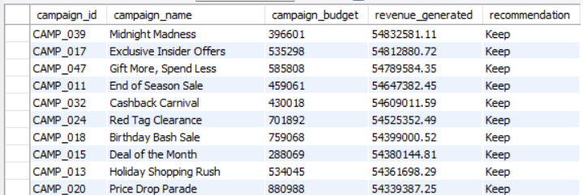Output:

Insights:

* All listed campaigns deserve "Keep" status
* Budgets range widely (₹288K–₹880K) with **no ROI correlation**
* Missing low-ROI campaigns in data

Recommendations:

* Equalize budgets at ₹500K for fair testing
* Require 200% ROI to retain funding
* Quarterly "Campaign Olympics" to retire weak ones